

A CASE STUDY REPORT
ON BIRTH, DEATH AND MIGRATION PROCESS IN WARD OFFICE

Submitted by: Submitted to Mandip Shrestha Anand K.C. Rijan Rijal Bipin Dawadi
CERTIFICATE
This is to certify that the case study report entitled “Birth, Death and Migration Process in Ward Office” has been carried out by Mandip Shrestha, Rijan Rijal, and Bipin Dawadi under my supervision, in partial fulfillment of the requirements for the course of Case Study III of the Bachelor of Science in Computer Science and Information Technology program at Prime College, affiliated with Tribhuvan University.
The report reflects the students’ own work, investigation, and field visit conducted at the concerned ward office, and it is recommended for evaluation.

..........................................
Anand K.C.
Project Supervisor
ABSTRACT
Every ward office in Nepal deals with three services almost every day: registering a birth, registering a death, and issuing a migration certificate when someone moves house for good. For this case study, we wanted to see how these three processes actually work on the ground, rather than just how they are described in official guidelines – what documents people are asked to bring, how long each step takes, what it costs, and where things tend to slow down.
To find out, we visited the ward office in Nagarjun, Ward No. 2, and spoke with the staff who process these applications day to day. What stood out was that the procedures themselves are reasonably clear once you know them. Applications are now filled out online, and once a form is submitted, the applicant receives a token number. Ward office staff then use this token number to look up and process the application.
To get a sense of what a more complete digital system might look like, we also built a small front-end prototype in Next.js that mirrors the three official forms for birth, death, and migration registration. While the ward office has already moved to online form submission, the prototype explores what a fuller system could look like beyond intake — for instance, how submitted records could be stored, retrieved, and cross-checked digitally rather than relying on manual lookup after the token stage. It does not connect to a database or a server; it is meant only to illustrate the interface and structure such a system could have. The report closes with a few suggestions on how the ward office could build toward this kind of end-to-end digital system
ACKNOWLEDGEMENTS
We extend our sincere appreciation to all individuals who have contributed to the completion of this project report. We would like to express our deep gratitude to our project supervisor, Mr. Anand K.C, whose constant guidance, encouragement, and valuable recommendations have been instrumental in the creation of this report.
We are also indebted to Ms. Rolisha Sthapit, the BSc. CSIT Coordinator at Prime College, for her unwavering support and assistance throughout the entire project. Her guidance from the initial stages until completion has been invaluable to our success. We would like to thank the seniors and teaching staff of the B.Sc. CSIT department for their continuous support, which greatly aided us in the successful completion of our project. The non-teaching staff of the B.Sc.CSIT department also deserves our heartfelt gratitude for their timely assistance.
We would also like to acknowledge our colleagues, whose support and inspiration played a significant role in completing this report. Their collaborative efforts and encouragement have been a vital part of our journey.
In conclusion, we are grateful to everyone who has contributed to this project report, and we express our deep appreciation for their invaluable assistance and support throughout the process.
With Respect,
Mandip Shrestha
Rijan Rijal
Bipin Dawadi
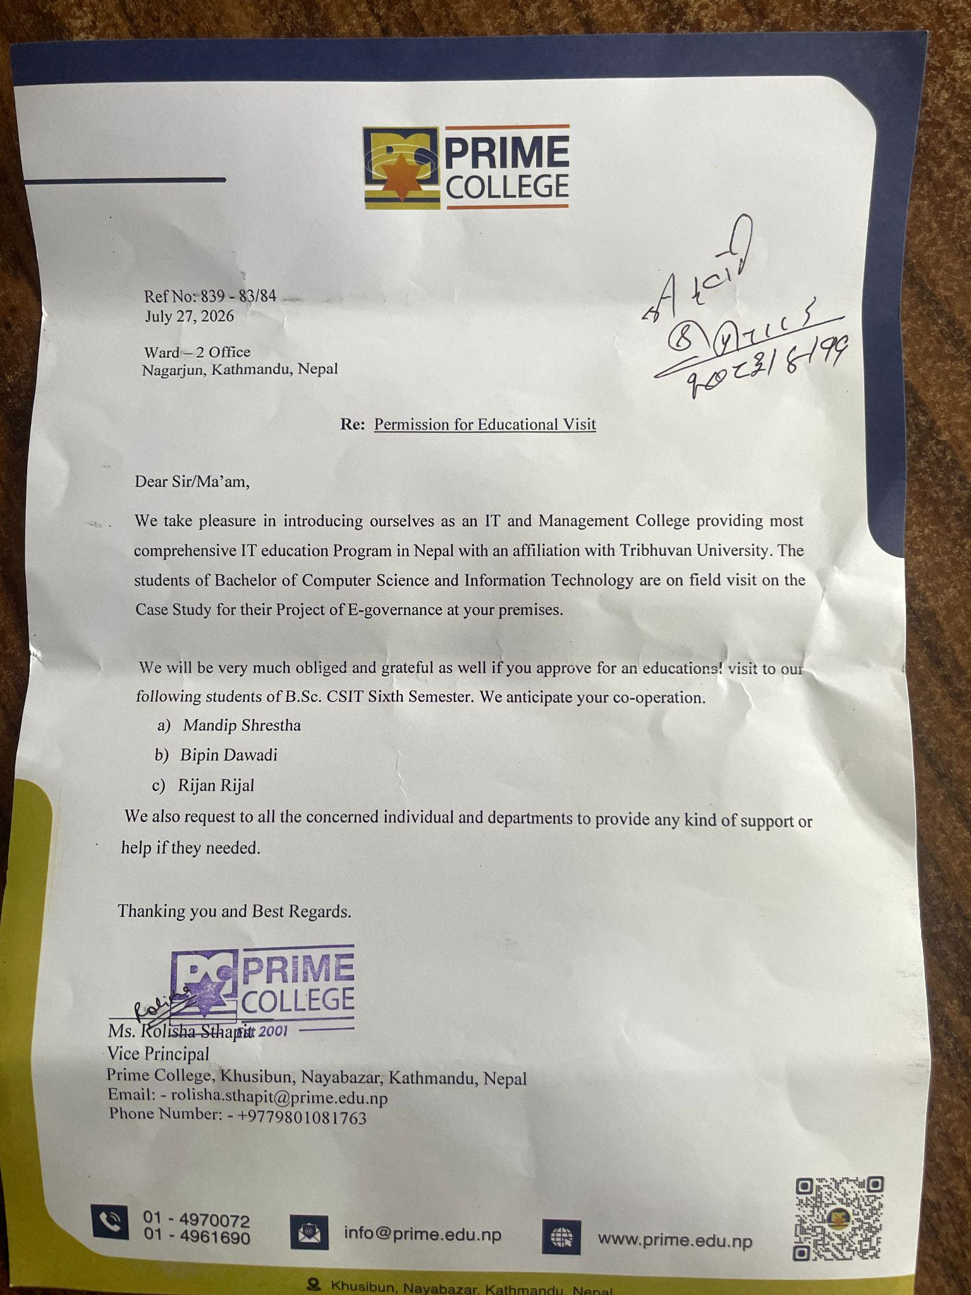

TABLE OF CONTENTS

CHAPTER 1: INTRODUCTION 1
1.1 Introduction 1
1.2 Objective of the Study 1
1.3 Scope and Limitations of the Study 2
1.4 Methodology of the Study 2
CHAPTER 2: REVIEW OF CASE STUDY 3
2.1 Birth Certification Process 3
2.1.1 Procedure 3
2.1.2 Documents 4
2.1.3 Things to Remember 4
2.2 Death Certification Process 9
2.2.1 Procedure 9
2.2.2 Special Cases 9
2.2.3 Documents 10
2.2.4 Eligibility 10
2.3 Migration Certificate 13
2.3.1 Eligibility 13
2.3.2 Required Documents 13
2.3.3 Procedure 13
2.3.4 Cost 14
CHAPTER 3: APPLICATION DEVELOPMENT 16
CHAPTER 4: CONCLUSION AND SUGGESTIONS 21
Conclusion 21
APPENDIX 23
Field Visit 23
REFERENCES 25

LIST OF FIGURES
Figure 1: Online Birth Certification Form
Figure 2: Birth Certification Process
Figure 3: Online Death Certification Process
Figure 4: Migration Certification Process
Figure 5: Application – Birth Registration Interface
Figure 6: Application – Death Registration Interface
Figure 7: Application – Migration Registration Interface
Figure 8: Field Visit Photograph 1
Figure 9: Field Visit Photograph 2

CHAPTER 1: INTRODUCTION

1.1 Introduction
Birth, death, and migration registration are core functions of ward offices — they underpin accurate population records, legal documentation, and fair distribution of government resources. This case study looks closely at these processes as they currently stand: how registrations are submitted, how they are processed and tracked internally, and where gaps remain despite recent moves toward digitization.

1.2 Objective of the Study
Through this study, we visited a ward office and spoke directly with the staff who handle these applications day to day. While form submission has already shifted online in some processes, much of what happens afterward — verification, record-keeping, and retrieval of past applications — still relies on manual effort. This creates room for delays and inconsistencies even after a form has been submitted. The goal of this report is not just to identify these gaps but to suggest practical ways to close them, including a small prototype system built to explore what a more complete digital workflow could look like. The sections that follow go into more detail on the specific challenges we found and the improvements we recommend.
This study looks at all three registration types — birth, death, and migration — as they are handled at the ward office, from the moment a form is submitted online to when the record is finally filed. Specifically, the study aims to:
- Understand how the process works, start to finish. This means tracing the steps a record goes through, who is responsible for what along the way, and spotting any steps that seem repetitive or unnecessary.
- Check how accurate and reliable the data is. This involves looking at how information is entered, how it gets cross-checked, and what happens when mistakes are found and need to be fixed.
- See how much of the process is actually digital. While forms are submitted online and tracked using tokens, much of what happens next — like storing and retrieving records — may still depend on manual work. This objective looks at where that gap is.
- Find the slow points and suggest fixes. The goal here is to identify where delays happen and offer practical ways to make the process faster and smoother.

1.3 Scope and Limitations of the Study
This study focuses on three services offered at the ward level: birth registration, death registration, and internal migration certification. For each, we looked at the steps involved, the documents required, who is eligible, and roughly how much it costs and how long it takes.We also built a small prototype application to show how part of this process could be handled digitally, beyond the online form submission already in place.
We did not look into other services handled by the ward office or the District Administration Office, such as marriage registration or citizenship, since those fall outside the scope of this study. It's also worth noting that our observations are based on a single field visit, so there may be small variations in how the process plays out depending on the ward, the season, or the officer handling a particular case — details we simply didn't have the chance to observe. Lastly, the prototype we built is front-end only, with no database behind it, so it should be seen as a proof of concept rather than a system ready to replace the current process.

1.4 Methodology of the Study
To put this report together, we relied mainly on first-hand observation, backed up by some background research:
- Field visit: We visited the ward office in person to see how birth, death, and migration applications are actually processed, and to talk to staff about how things work day to day.
- Conversations with staff: A few informal conversations with ward office personnel helped us understand the practical side of things — what usually causes delays, what documents people tend to forget, and similar day-to-day issues.
- Cross-checking with official sources: We compared what we observed against government portals and published guidelines to make sure the fees, timelines, and eligibility rules described in this report are accurate.
- Building the prototype: Based on what we saw at the ward office, we built a simple Next.js front-end that mirrors the same information captured in the online forms, to explore what a more complete digital workflow could look like.

CHAPTER 2: REVIEW OF CASE STUDY

2.1 Birth Certification Process
Birth registration is the first official record of a person's identity, and it plays a foundational role in accessing services such as school admission, passports, and citizenship later in life. In Nepal, the process has recently shifted to include an online component: applicants fill out a form through the Department of Civil Registration portal and receive a token number, which is then used at the local ward office to complete verification and issue the certificate. This section walks through that process step by step, based on what we observed and confirmed during our visit to the ward office.

2.1.1 Procedure
Registering a birth in Nepal now involves both an online step and an in-person visit to the ward office. Registration is free if completed within 35 days of birth.
- Filling the online form: A parent or family member visits the Department of Civil Registration portal and fills in the child's birth details along with the parents' information. Once submitted, the system generates a token number.
- Gathering documents: Alongside the token number, the family gathers the required documents — typically proof of the parents' identity and, where applicable, a hospital birth notification.
- Visiting the ward office: Within 30 to 35 days of the birth, the family brings the token number and documents to their local ward office.
- Verification: The ward registrar looks up the application using the token number, checks the submitted details against the documents provided, and verifies that everything is accurate and complete. If anything is missing or unclear, they may ask for additional documents or clarification.
- Issuing the certificate: Once verified, the registrar issues the official birth certificate (Janma Darta), which includes the child's name, the parents' names, and a unique registration number. Parents are expected to check the certificate carefully before leaving to make sure all the details are correct.
- Requesting extra copies: If needed, parents can request additional copies of the certificate — useful for school admissions, travel, or other purposes — usually for a small additional fee.

2.1.2 Documents
Proof of birth is the most important document required for obtaining a birth certificate. It can include:
- Hospital birth report: If the child was born in a hospital, a birth report or certificate from the hospital is required.
- Midwife’s certificate: If the child was delivered by a midwife, a certificate issued by the midwife may be required.
- Home birth certificate: If the child was born at home, a home birth certificate issued by a registered midwife or attending medical professional may be required.
- Parent’s identification documents: Identification cards such as national ID cards, driver’s licenses, or passports for both parents.
- Marriage certificate (if applicable): Required to establish the legal relationship between the parents.

2.1.3 Things to Remember
- Marriage certificate of the parents is required. To register a child's birth, the parents' marriage certificate must be submitted along with the other documents, to establish the legal relationship between the child and both parents.
- Remember your token number. If the online form is filled out in advance, the applicant receives a token number, which the ward office staff use to pull up the application. Keep this number safe until the process is complete.
- If the online form isn't filled in advance, the ward office will do it for you. In this case, staff fill out the form directly at the office, but this requires the original citizenship certificates of both parents, along with the names of the child's grandparents, for verification purposes.
- Second marriage cases need extra care. If either parent has been married more than once, a digital proof certificate confirming the current marriage is required, and it must not have been modified. Additionally, either the father or the mother must be present in person at the ward office.
- Choose the right office. Registration should be done at the ward office corresponding to where the child was born or where the parents permanently reside.
- Check the form carefully. Make sure names, dates, and other details are entered correctly, since even small spelling errors can cause issues later, such as during passport or school applications.
- Bring valid, original documents. This includes citizenship certificates, the marriage certificate, and — if the child was born in a hospital — the hospital birth report.
- Fees depend on timing. Registration is free if completed within 35 days of birth. After 35 days, a late fee of Rs. 200 applies.
- Ask about processing time. Confirm how long the certificate will take to process, and keep any token numbers or receipts you're given in case you need to follow up.
- Make copies once you receive the certificate. Keep several copies safe for future use, such as school admission or passport applications.

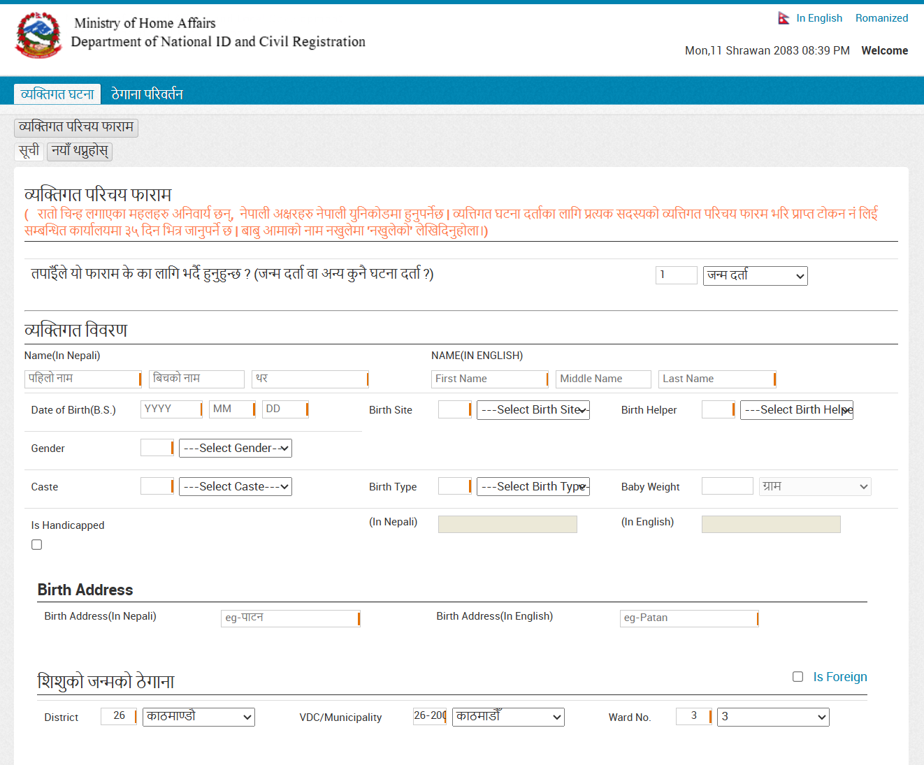
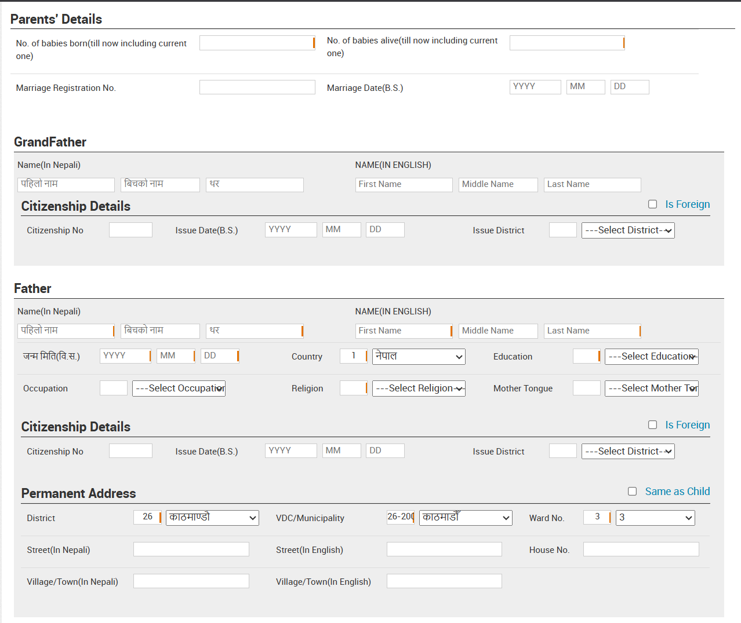
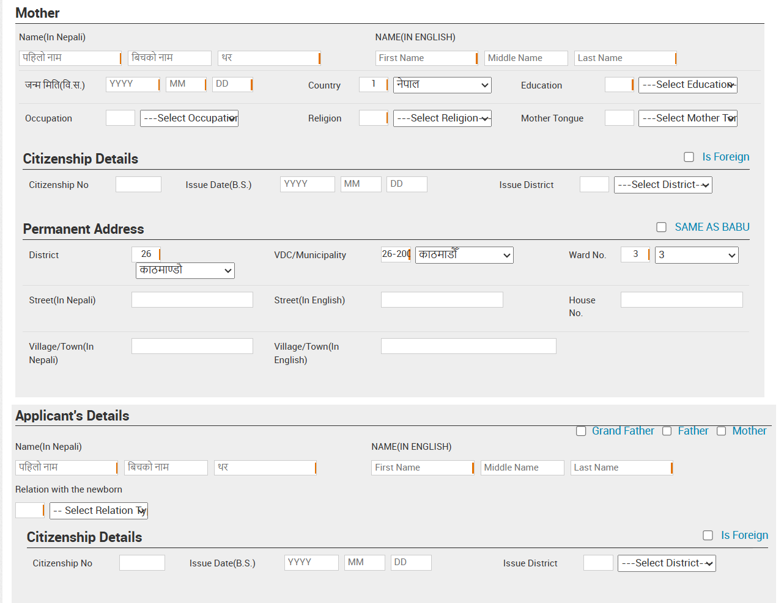
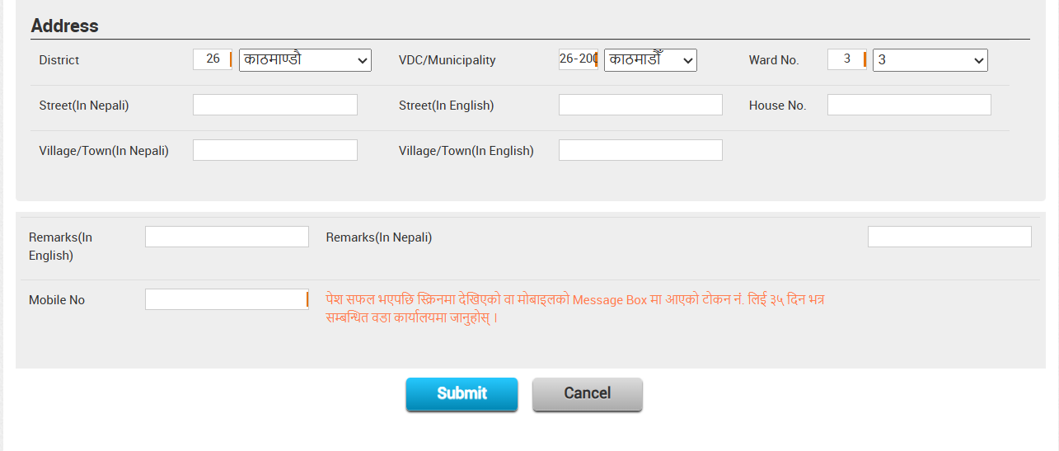
Figure 1: Online Birth Certification Form
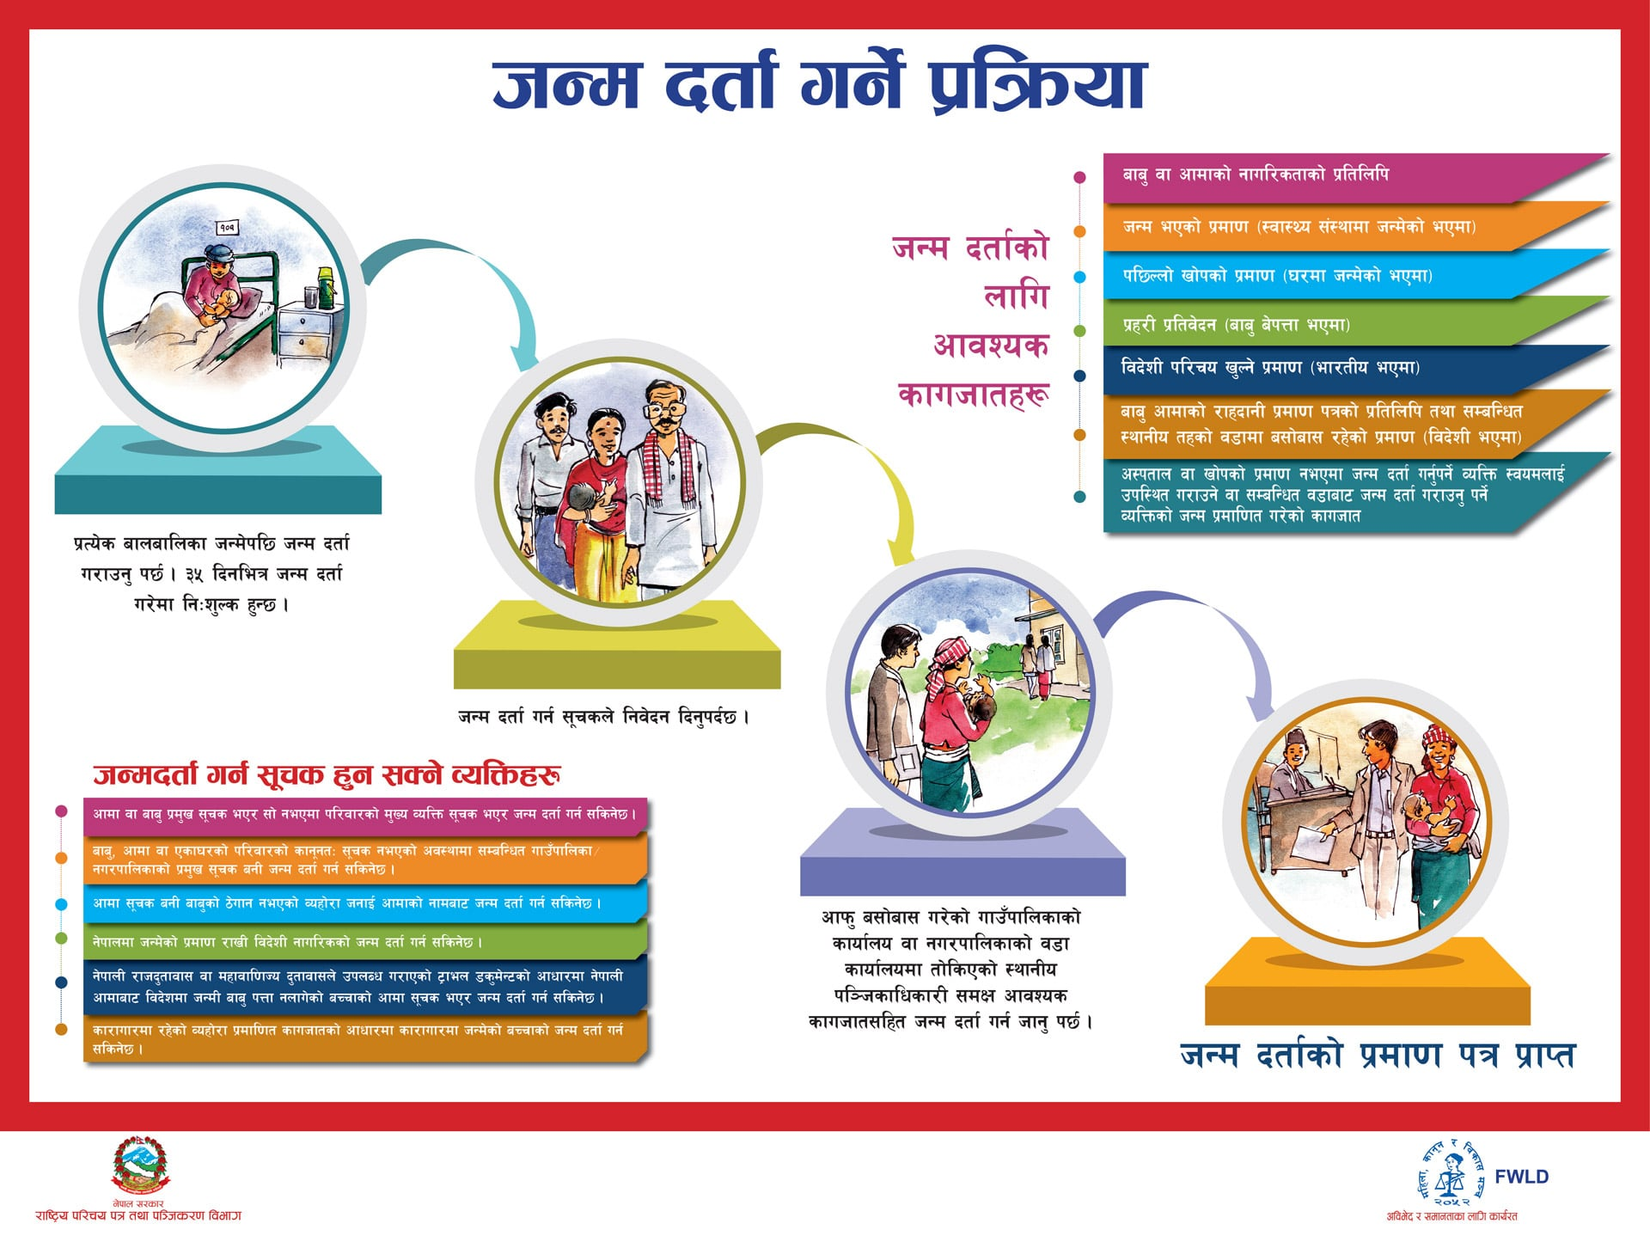
Figure 2: Birth Certification Process

2.2 Death Certification Process
A death certificate is the official legal record confirming that a person has died, and it is required for matters such as settling inheritance, closing bank accounts, claiming insurance, and updating family records. In Nepal, death registration follows a similar process to birth registration: an online form is filled out first, generating a token number, which is then used at the ward office to complete verification and issue the certificate. This section outlines that process, based on our field visit and conversation with ward office staff.

2.2.1 Procedure
- Filling the online form: A family member (the suchak, or informant) fills out the death registration form through the online portal, providing the deceased's name, date and place of death, and related details. Submitting the form generates a token number.
- Visiting the ward office: The informant brings the token number and required documents to the ward office within 35 days of the death.
- Verification: Staff use the token number to locate the application, then verify the submitted details against the documents provided. The deceased's permanent residence must match ward records, since death registration is tied to the person's registered address.
- Confirming the informant's eligibility (hakdar): Ward staff confirm that the person reporting the death is an eligible next-of-kin. Typically, this is the wife or son; if neither is available, the daughter; and if there is no immediate family, a brother or another relative within three generations of the deceased.
- Paying the fee: Registration is free if completed within 35 days of the death. After 35 days, a late fee of Rs. 200 applies.
- Issuing the certificate: Once verified, the ward office issues the official death certificate.

2.2.2 Special Cases
- Missing persons: A person who has gone missing can only be legally declared dead after 12 years. If the missing person is later found alive, this declaration can be revoked.
- Death abroad: If a Nepali citizen dies outside Nepal, the death must be verified through the Nepali embassy (Rajdoot) in that country before it can be registered.

2.2.3 Documents
- Citizenship certificate of the deceased
- Citizenship certificate of the informant
- Hospital or medical certificate stating the cause of death, if the person died in a hospital
- Proof of death, such as an eyewitness account, postmortem report, police case file, or circumstantial evidence, in cases where a hospital record is not available
- Time, location, and date of death

2.2.4 Eligibility
- The deceased must be a Nepali citizen.
- The death must be confirmed through appropriate documentation or evidence.
- If the person is missing, they can be legally declared dead only after 12 years.
- The person reporting the death (informant) must be an eligible next-of-kin, in the order noted in the procedure above.

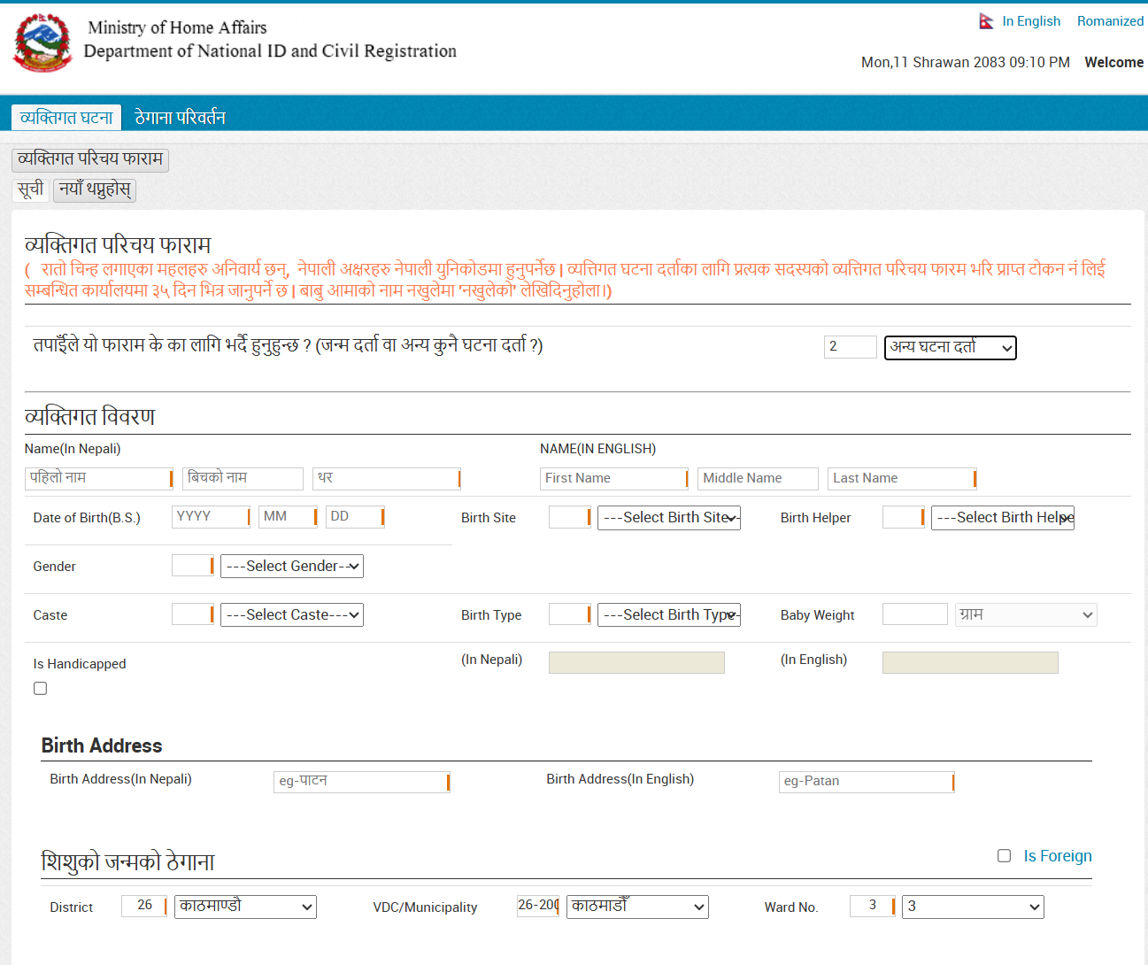
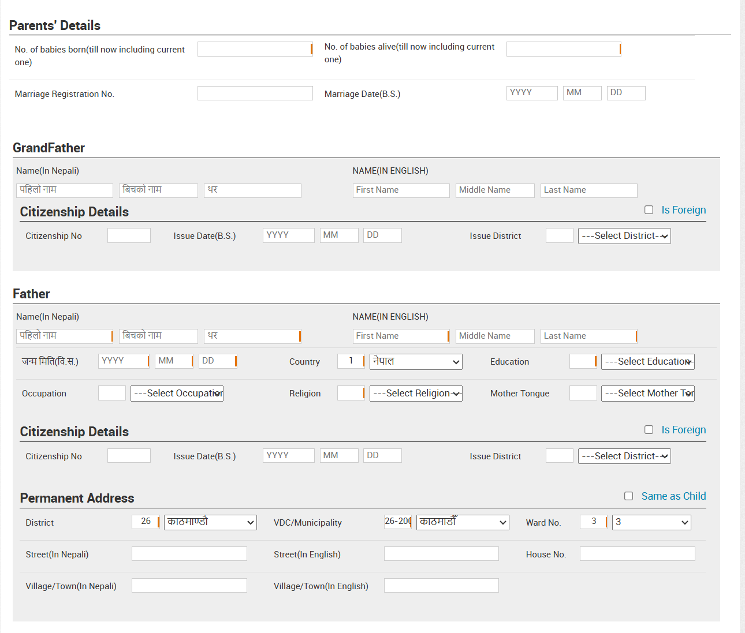
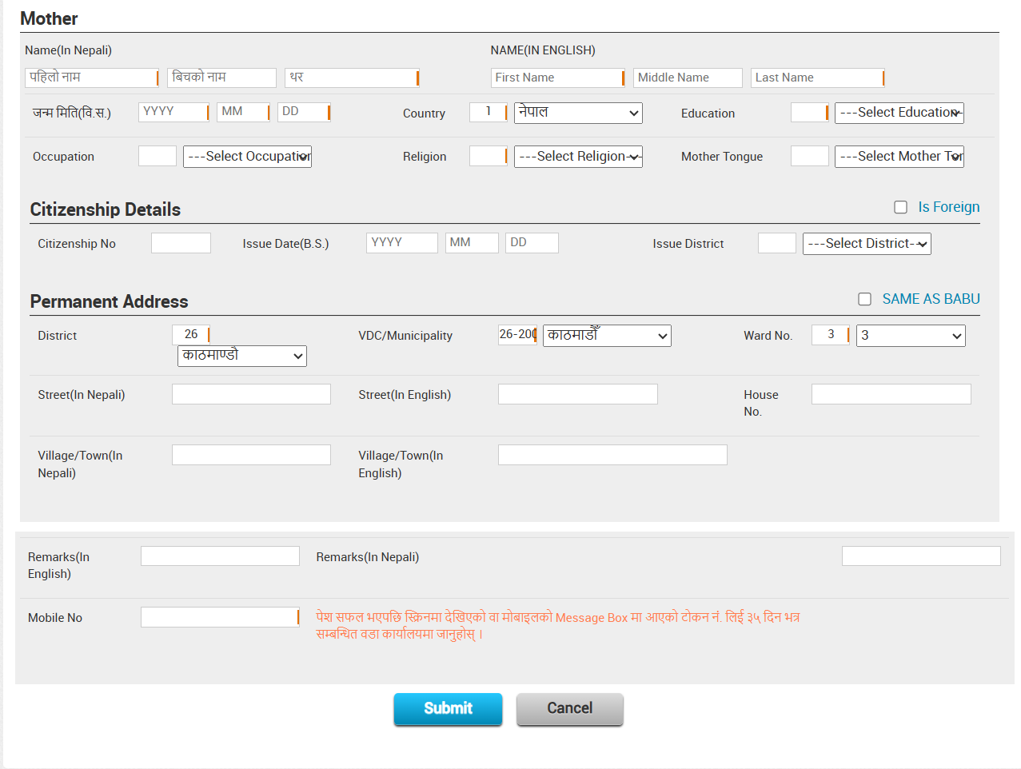
Figure 3: Online Death Certification Process

2.3 Migration Certificate
A Migration Certificate is an official confirmation from the government that a person has changed their permanent home address. Whether it is required depends on how long the person plans to stay in the new place: a brief stay may not require it, while relocating permanently or for a substantial period typically requires this certificate to make the change of address official.

2.3.1 Eligibility
There are two conditions that must be met to be eligible for a migration certificate:
- The applicant must be able to prove that they were born within Nepal and that their parents are Nepali citizens.
- The applicant must be a Nepali citizen.

2.3.2 Required Documents
- Citizenship of the migrant(s), or birth certificate if minors are present
- A formal letter stating the reason for migration
- Letter of approval (lagat hastantaran) from the ward office of departure
- Land ownership document (लालपुर्जा) or proof of a house at the new location
- Details of all family members included in the move — everyone listed in the household must be included on the form

2.3.3 Procedure
- Filling the form: The applicant fills out the migration application either online or at the old ward office. All family members migrating together must be listed on the same form.
- Getting a token number: If filled online, the system generates a token number, which is used by ward office staff to look up the application.
- Requesting approval: The applicant submits a letter to the old ward office stating the reason for migration, the number of people migrating, and the intended destination, along with the required documents.
- Receiving the lagat hastantaran: The old ward head signs and issues the lagat hastantaran (record transfer) letter, along with a number that carries the record to the new location.
- Registering at the new ward office: After arriving at the new location, the applicant presents the approved letter, the lagat hastantaran number, and supporting documents to the new ward office. The new ward office can only sign to confirm receipt — it cannot modify any of the details already recorded by the old ward office.

2.3.4 Cost
- Migration registration is free if completed within 35 days of the move. After 35 days, a late fee of Rs. 200 applies.
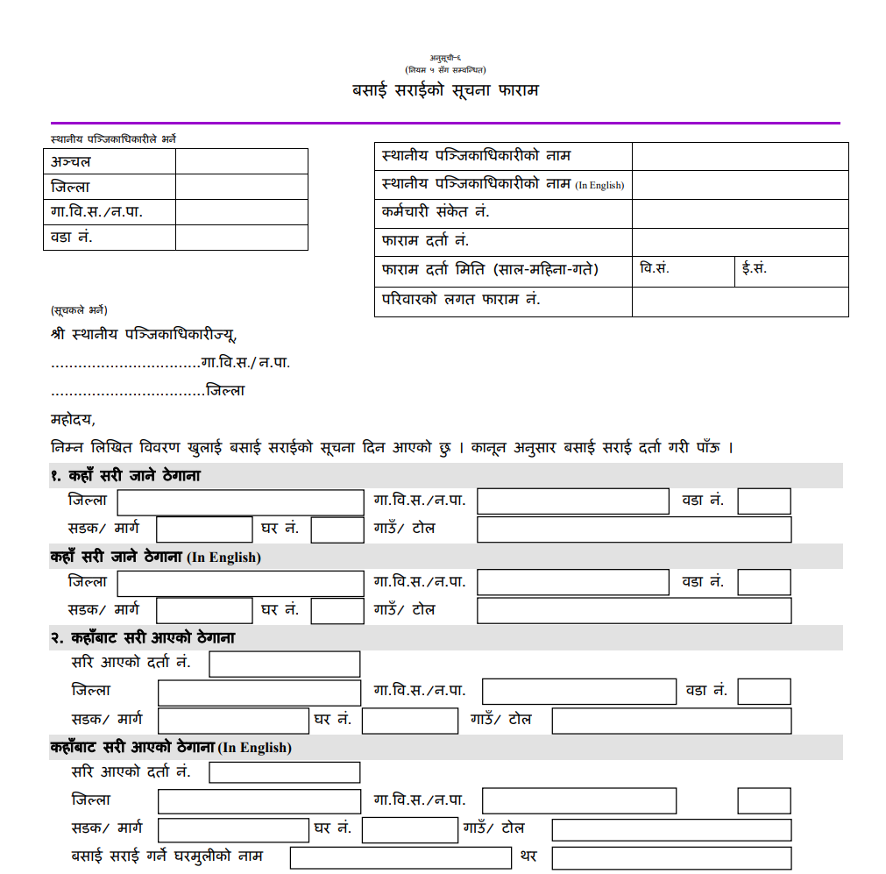
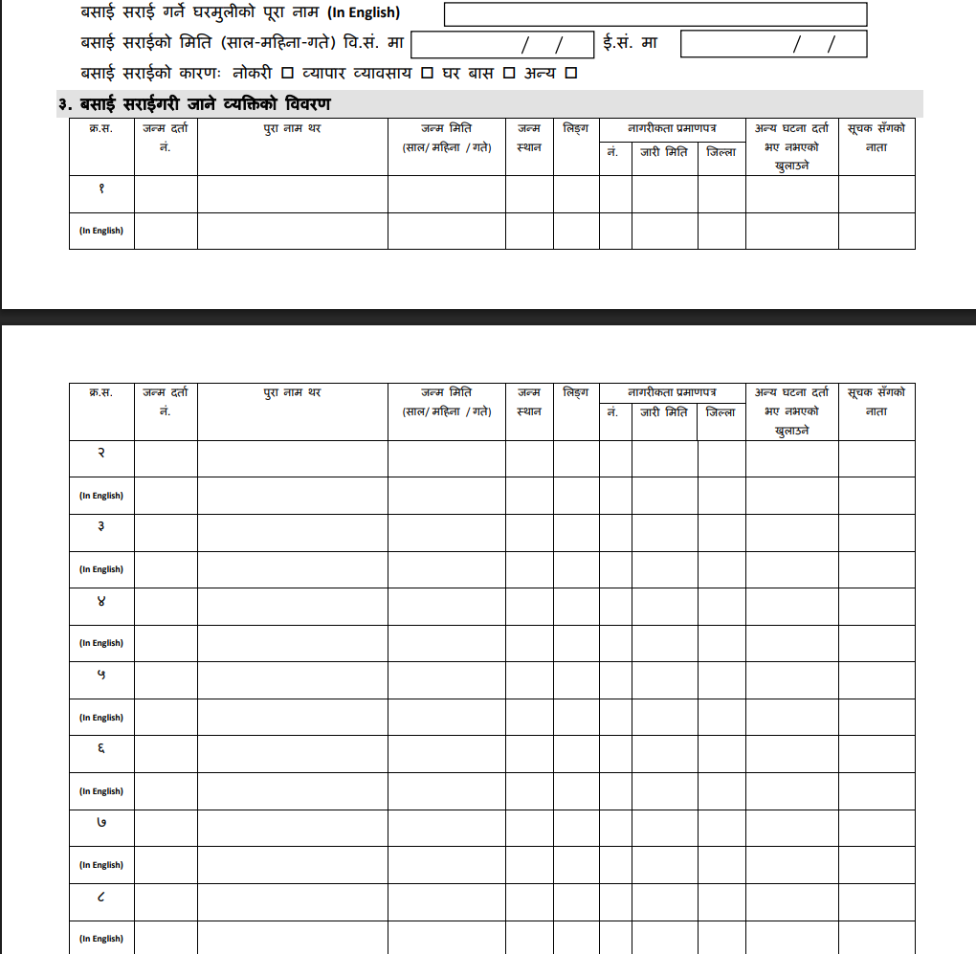
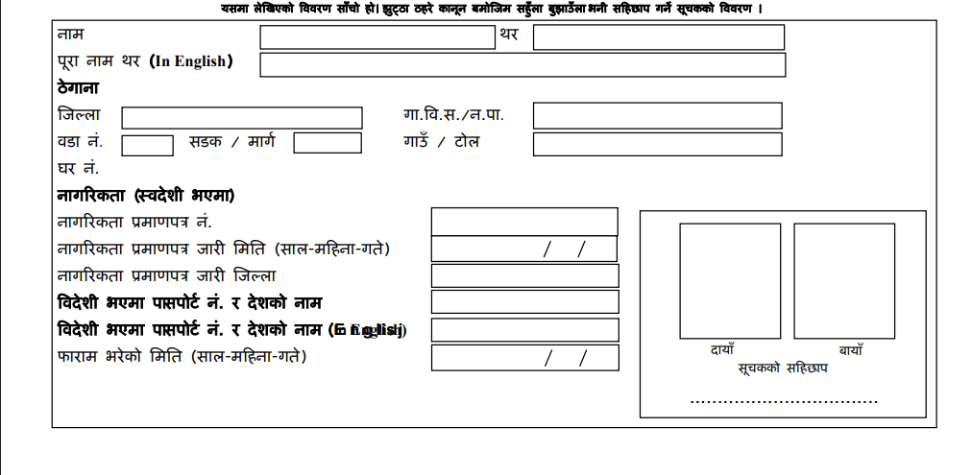
Figure 4: Migration Certification Process

CHAPTER 3: APPLICATION DEVELOPMENT
Once we had a clear picture of how birth, death, and migration registration actually work at Nagarjun Ward No. 2 — including the online forms, the token system, and the specific verification steps staff follow — we built a small prototype to explore what a more complete digital system might look like. We used Next.js, mainly because it let us put together a clean, responsive interface quickly, without needing to set up a full application stack.
The ward office has already moved form submission online: applicants fill out a form and receive a token number, which staff use to locate the application. What we noticed, though, is that everything after that point still depends on manual work. Staff cross-check citizenship documents by hand, verify family details like grandparents' names when a form was filled in-office rather than online, and confirm eligibility rules — such as who qualifies as the hakdar for a death registration, or how a second marriage is verified for a birth registration — without any system to record or retrieve that verification later. Our prototype focuses on this gap. It mirrors the three official forms — birth, death, and migration registration — with the same fields their paper and online counterparts use: applicant details, family or relative information, document uploads, and a declaration section. On submission, it shows a confirmation message, similar to what the actual online portal does.
To be clear about its limits: this prototype has no backend, no database, and nothing is stored once a form is submitted. It only demonstrates the interface — what structured data entry could look like for these three services. It does not attempt to solve the verification and record-keeping problems we observed; it is meant to show a starting point for what that solution's front end could look like, if the ward office chose to build on it.
How this connects back to the problems we identified
In the introduction to this study, we noted three recurring issues with the current paper-heavy process: manual cross-checking of documents, handwriting that is not always easy to read, and no simple way to look up an old record once it has been filed away. Our prototype addresses these unevenly, and it is worth being clear about which parts it actually helps with:
- Illegible handwriting and inconsistent data entry — this is the problem the prototype solves most directly. Structured digital fields, dropdowns, and required-field validation replace handwritten entries entirely, so information arrives complete and in a consistent format every time.
- Manual cross-checking — the prototype helps here only partially. Because its fields mirror exactly what staff told us they verify by hand (father's citizenship number, hakdar relationship, land ownership document number, and so on), the information arrives already organized in the format staff need for verification — but the actual checking is still a manual step outside the prototype itself.
- Difficulty retrieving old records — the prototype does not solve this. Since there is no database, nothing submitted through the prototype can be searched or retrieved later. Closing this gap would require the backend and record-lookup features we outline in our suggestions in Chapter 4.
In short, the prototype is best understood as a first step — it demonstrates what clean, structured intake could look like, while leaving the deeper problems of verification and retrieval as the next stage of a more complete system.
Key Points
- Three forms built for birth, death, and migration registration, matching the fields used in the ward office's actual processes.
- Structured fields for details that are currently checked manually — for example, family member names, marriage status, and informant eligibility — the kind of information staff at Nagarjun Ward No. 2 told us they cross-verify by hand.
- Shows a confirmation message on submission, consistent with the existing online portal's behavior.
- Front-end only — no backend, database, or storage.
- Directly addresses handwriting/data-entry inconsistency; partially supports document cross-checking; does not yet address record lookup.
- A starting point for discussion, not a system ready for deployment.
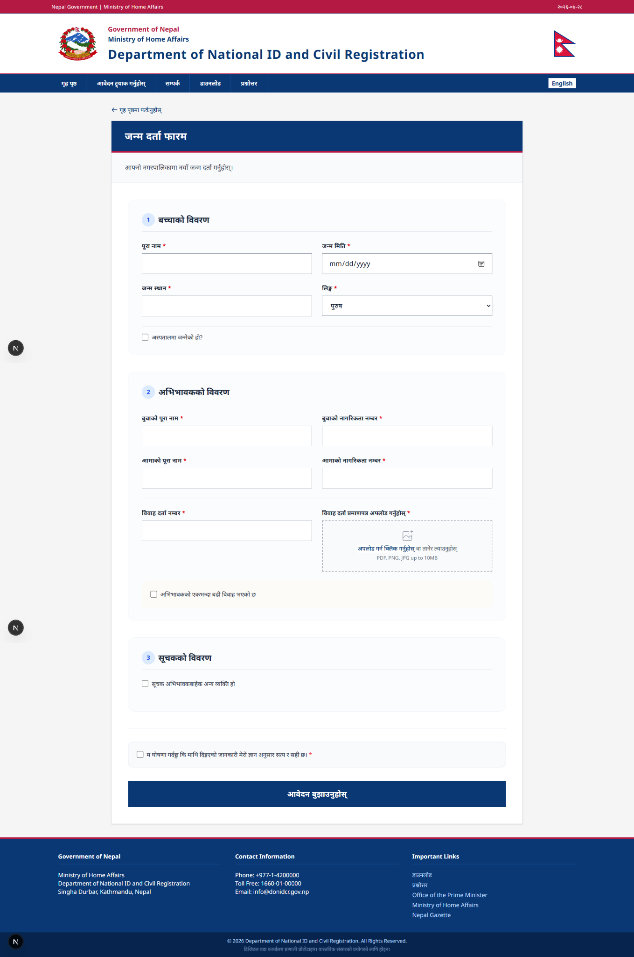
Figure 5: Application – Birth Registration Interface
Figure 6: Application – Death Registration Interface
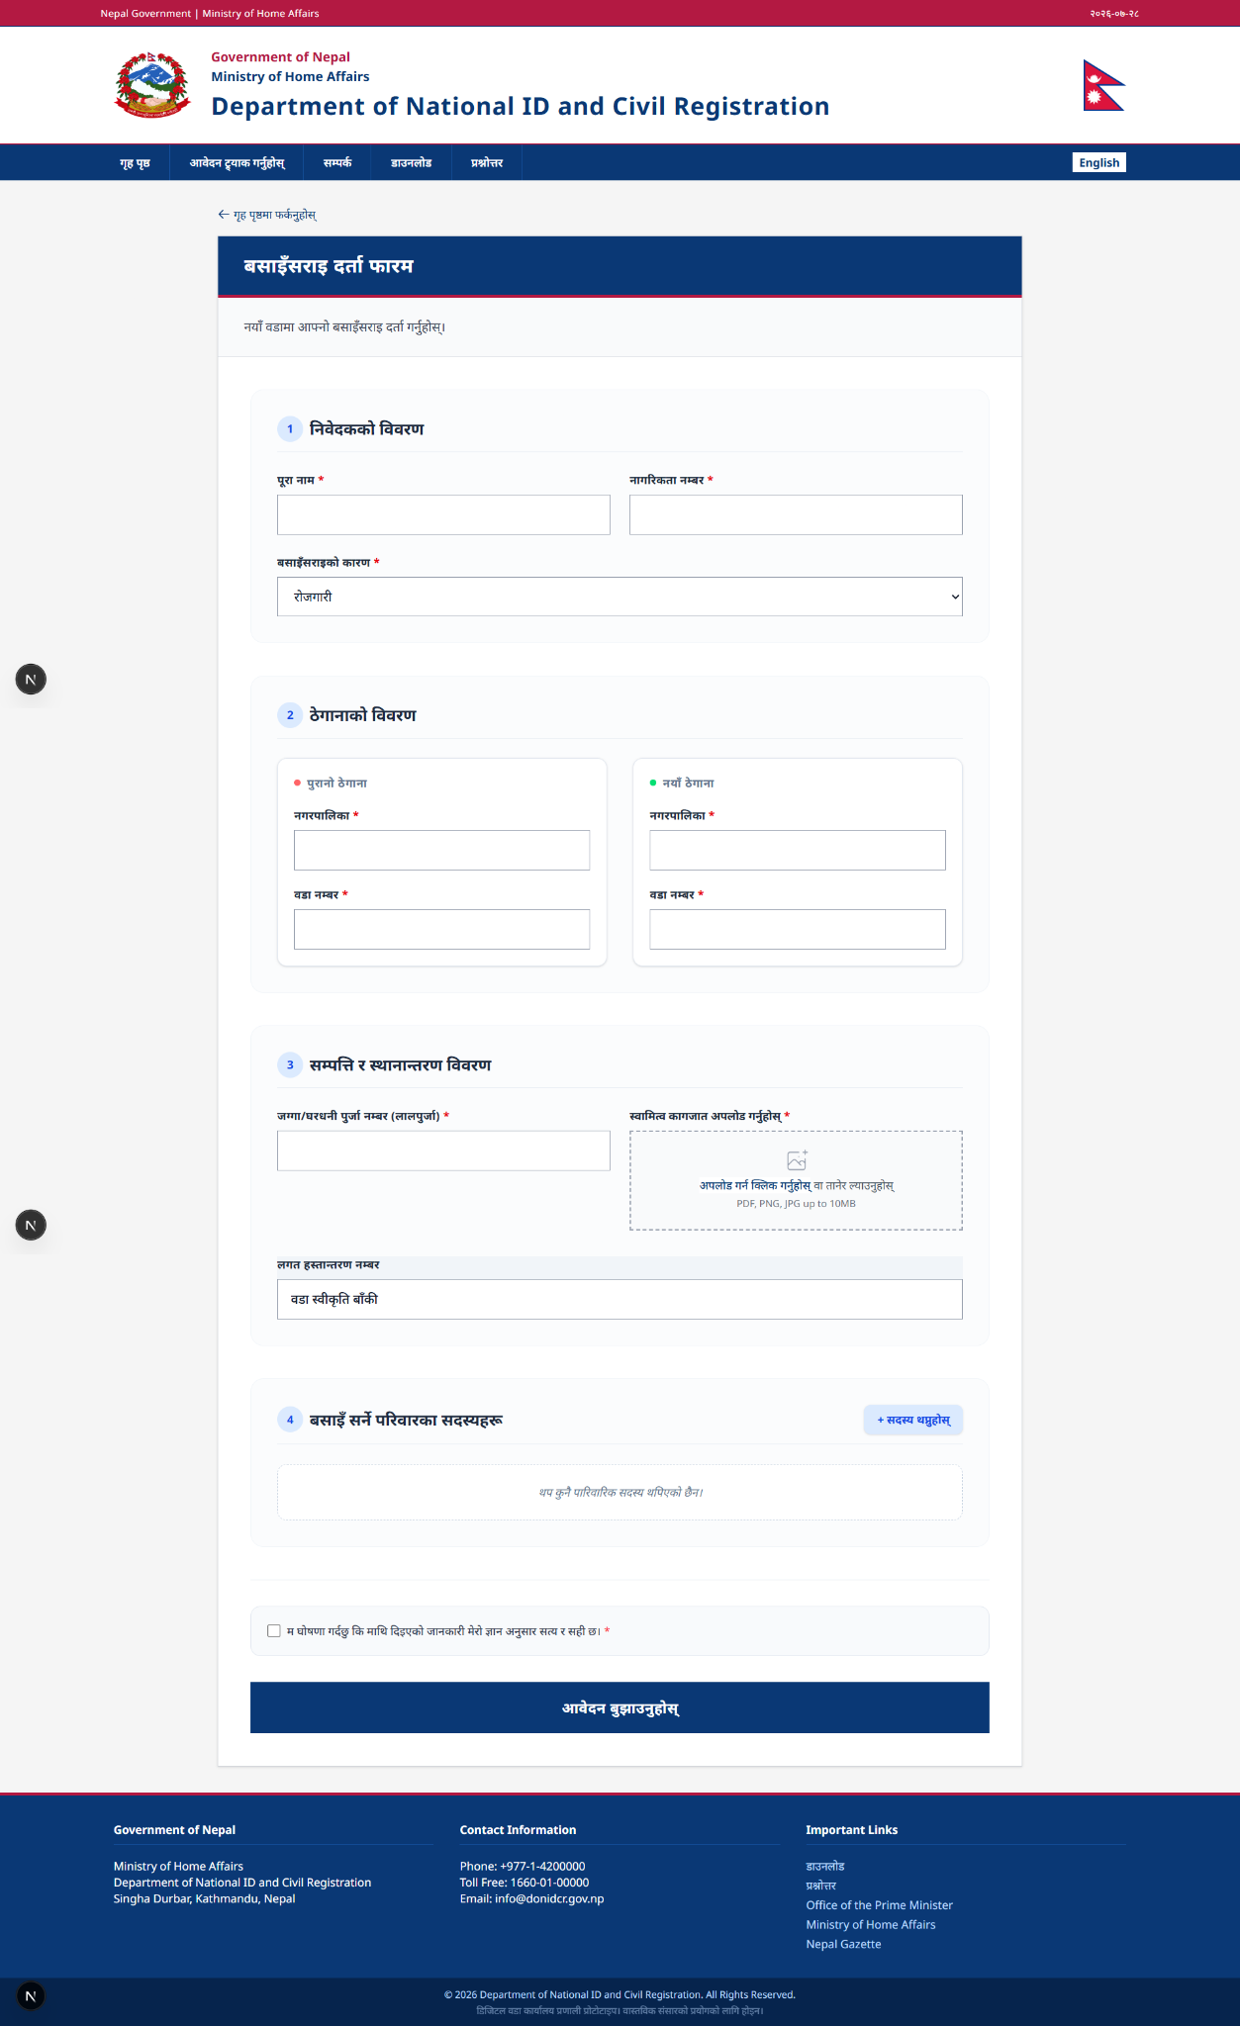
Figure 7: Application – Migration Registration Interface

CHAPTER 4: CONCLUSION AND SUGGESTIONS

Conclusion
Visiting Nagarjun Ward No. 2 and speaking directly with the staff who handle these applications made one thing clear: the process itself is not poorly designed. The rules — who can act as an informant, what documents are needed, how fees scale with timing — are consistent and well understood by the people applying them. The ward office has also already taken a real step toward modernization by moving form submission online and adopting a token system for tracking applications.
Where the friction remains is in everything that happens after a token is issued. Verifying a citizenship document, confirming a family relationship, checking whether a missing person has passed the 12-year threshold to be declared dead, or transferring a migration record between wards without allowing the receiving office to alter it — all of this still depends on staff working from paper and memory, case by case. None of it is a design flaw exactly; it is simply work that has not yet been brought into the same digital system as the form itself.
Building the prototype made this distinction concrete for us. It is one thing to collect information through a clean online form — the ward office already does that. It is a separate, harder problem to make that information searchable, verifiable, and easy to hand off between offices, which is where the real bottlenecks in this process still live. A complete solution would need to close that second gap, not just replicate the first.
More broadly, this study was a reminder of how much depends on these small, easy-to-overlook processes. A birth certificate, a death certificate, a migration record — each is often the first document that unlocks something larger: school admission, inheritance, voting rights, or a citizenship application. Getting these processes right, quietly and reliably, matters more than their paperwork appearance suggests.

Suggestions
- Build a real backend for the prototype, so that once a token is generated, the associated application data is actually stored and can be retrieved later — rather than existing only until the browser tab closes.
- Digitize the verification checklist itself. Many of the manual checks we observed — confirming a hakdar's relationship to the deceased, verifying a second marriage's documentation, matching a migrant's family list against the old ward's records — could be turned into structured fields with required supporting uploads, rather than staff cross-referencing physical documents by memory.
- Let the token number double as a lookup key, so both applicants and staff can check an application's status or history without a manual file search.
- Support the lagat hastantaran transfer digitally, so that when a family migrates, the new ward office can view the original record directly instead of relying solely on a paper letter that it isn't permitted to modify.
- Provide staff training alongside any new system, especially during a transition period, so the digital tool supports the existing verification knowledge staff already have rather than replacing it outright.
- Explore integration with the Nagarik App or the national civil registration portal, so applicants and ward staff are not maintaining separate, disconnected versions of the same record.

APPENDIX

Field Visit
Photographs taken during the field visit to the ward office are presented below.

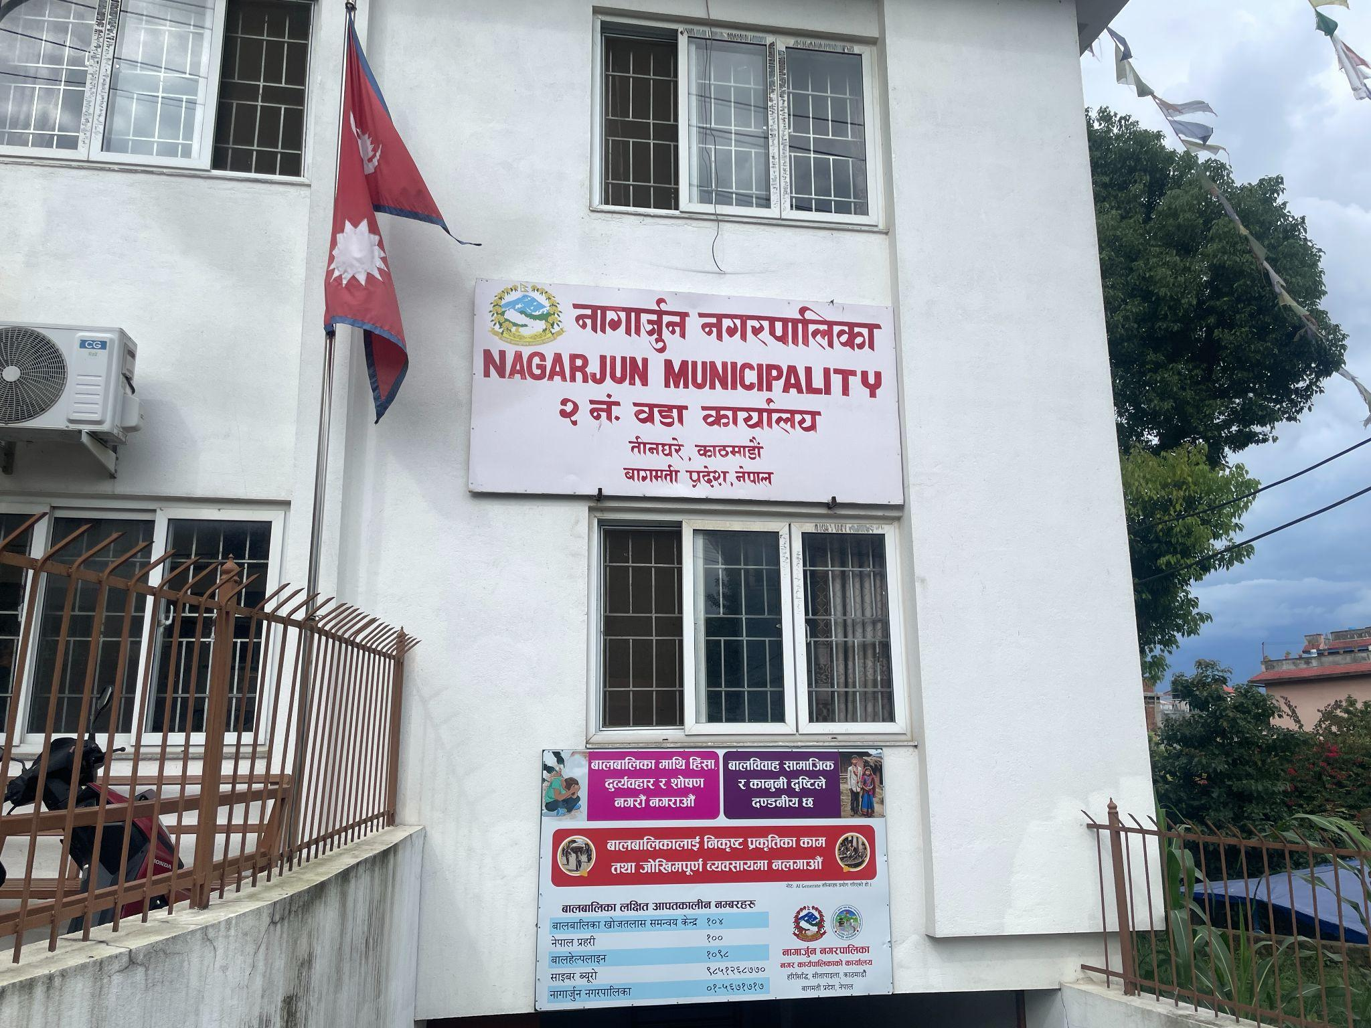
Figure 8: Field Visit Photograph 1

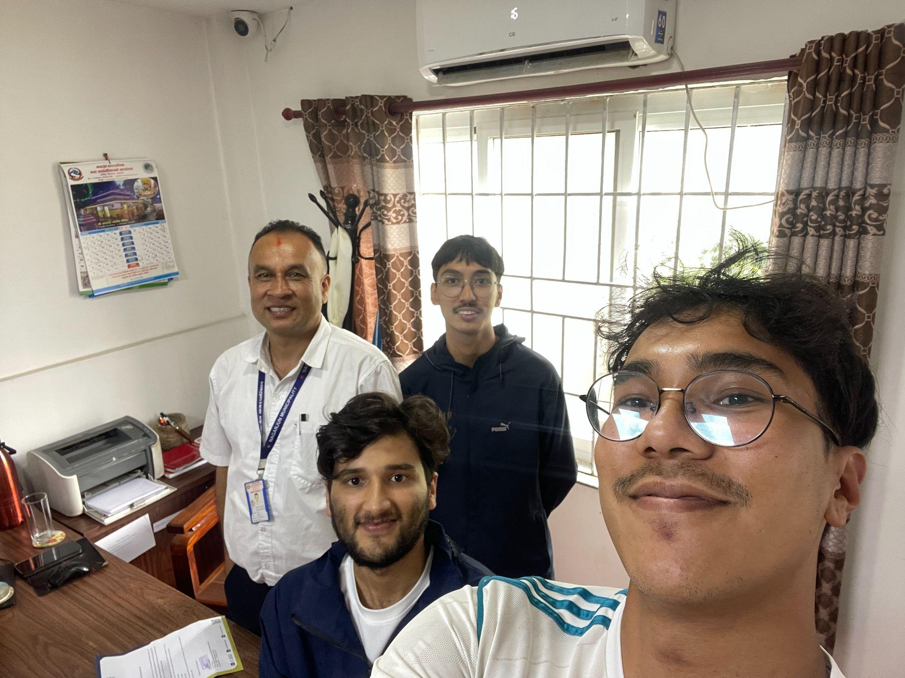
Figure 9: Field Visit Photograph 2

REFERENCES
[1] Next.js, "Getting Started," 2026. [Online]. Available: https://nextjs.org/docs/app/getting-started
[2] Department of National ID and Civil Registration, Government of Nepal, "Vital Registration Services (जन्म, मृत्यु, बसाइँसराइ दर्ता)," 2026. [Online]. Available: https://donidcr.gov.np
[3] Ward Office No. 2, Nagarjun Municipality, Kathmandu, personal communication (field visit and staff interview), 2026.

